How to Download Your Database

**Step 1: Log into your host (like Bluehost)**

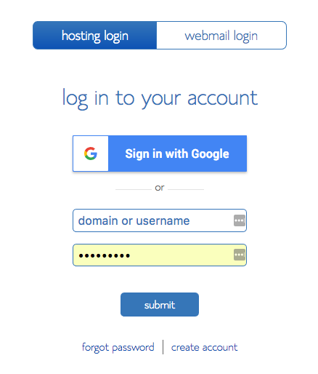

**Step 2: Go to your CPanel and find “Site Backup” under “Files.” Click on this. It may ask you to buy something or upgrade your backup service. This is not necessary though and you can just not buy it.**

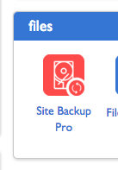

**Step 3: Step 2 will take you to the “Site Backup and Restore” page. Here, scroll down to MySQL and hit “Browse.”**

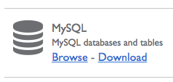

**Step 4: On the next page, find your databases for your WordPress install in the table. Check it off/select it. With your database selected, click “Download Zip.” It can be above or below the table, depending on your host.**





**Step 5: Your download should start right away, if it does not, check for a box that says “Click Here if your download does not start automatically.”**



**If these steps do not match your hosting service**, please refer to your host’s information pages. Typically, googling “*Your Host* download MySQL database* takes you somewhere with more information.

**If you still cannot find where to download your database**, contact your host’s customer service. I am not an expert on all the hosting services out there.